**CMPE 287 – Software Quality Assurance and Testing**

**Homework #2**

**First Name:** Harish

**Last Name:** Marepalli

**SJSU ID:** 016707314

**Professor:** Dr. Jerry Gao

**Question #1: Basis Path Software Testing (30%)**

Based on the given Java program below, please complete the following questions:

1. Generate a control program flow graph for Sort(…) based on the given Java program.(7%)
2. Compute its Cyclomatic number using cyclomatic complexity. (5%)
3. Generate a graph matrix based on your generated flow graph and compute the Cyclomatic metric. (5%)
4. Identify a basis path set (which consists of a number of basis paths) for Sort(.…) function. (6%)
5. List the basis set of test cases (including test inputs and outputs for each test case) (7%)

Java Program to Implement Selection-Sort(….)

<https://www.geeksforgeeks.org/selection-sort/>

**Answer:**

**A.** The flow chart Sort method for the given java program is as follows.

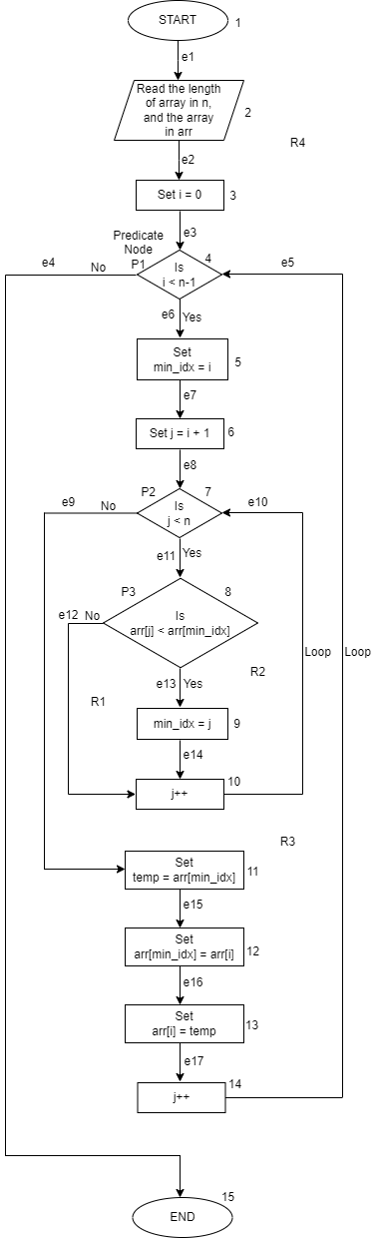

**B.** Cyclomatic Complexity Computation:

M(G) = 4 regions (R1, R2, R3, and R4 from the above flow chart)

M(G) = |E| - |N| + 2 = 17 – 15 + 2 = 4 (In the above flow chart, there are 17 edges indicated as e1, e2, …, e17 and 15 nodes indicated as 1, 2, …, 15)

M(G) = |P| + 1 = 3 + 1 = 4 (In the above flow chart, there are 3 predicate nodes indicated as P1, P2, P3)

**C.** Graph Matrix:

|  |  |  |  |  |  |  |  |  |  |  |  |  |  |  |  |  |
| --- | --- | --- | --- | --- | --- | --- | --- | --- | --- | --- | --- | --- | --- | --- | --- | --- |
|  | 1 | 2 | 3 | 4 | 5 | 6 | 7 | 8 | 9 | 10 | 11 | 12 | 13 | 14 | 15 |  |
| 1 | 0 | 1 | 0 | 0 | 0 | 0 | 0 | 0 | 0 | 0 | 0 | 0 | 0 | 0 | 0 | 1-1=0 |
| 2 | 0 | 0 | 1 | 0 | 0 | 0 | 0 | 0 | 0 | 0 | 0 | 0 | 0 | 0 | 0 | 1-1=0 |
| 3 | 0 | 0 | 0 | 1 | 0 | 0 | 0 | 0 | 0 | 0 | 0 | 0 | 0 | 0 | 0 | 1-1=0 |
| 4 | 0 | 0 | 0 | 0 | 1 | 0 | 0 | 0 | 0 | 0 | 0 | 0 | 0 | 0 | 1 | 2-1=1 |
| 5 | 0 | 0 | 0 | 0 | 0 | 1 | 0 | 0 | 0 | 0 | 0 | 0 | 0 | 0 | 0 | 1-1=0 |
| 6 | 0 | 0 | 0 | 0 | 0 | 0 | 1 | 0 | 0 | 0 | 0 | 0 | 0 | 0 | 0 | 1-1=0 |
| 7 | 0 | 0 | 0 | 0 | 0 | 0 | 0 | 1 | 0 | 0 | 1 | 0 | 0 | 0 | 0 | 2-1=1 |
| 8 | 0 | 0 | 0 | 0 | 0 | 0 | 0 | 0 | 1 | 1 | 0 | 0 | 0 | 0 | 0 | 2-1=1 |
| 9 | 0 | 0 | 0 | 0 | 0 | 0 | 0 | 0 | 0 | 1 | 0 | 0 | 0 | 0 | 0 | 1-1=0 |
| 10 | 0 | 0 | 0 | 0 | 0 | 0 | 1 | 0 | 0 | 0 | 0 | 0 | 0 | 0 | 0 | 1-1=0 |
| 11 | 0 | 0 | 0 | 0 | 0 | 0 | 0 | 0 | 0 | 0 | 0 | 1 | 0 | 0 | 0 | 1-1=0 |
| 12 | 0 | 0 | 0 | 0 | 0 | 0 | 0 | 0 | 0 | 0 | 0 | 0 | 1 | 0 | 0 | 1-1=0 |
| 13 | 0 | 0 | 0 | 0 | 0 | 0 | 0 | 0 | 0 | 0 | 0 | 0 | 0 | 1 | 0 | 1-1=0 |
| 14 | 0 | 0 | 0 | 1 | 0 | 0 | 0 | 0 | 0 | 0 | 0 | 0 | 0 | 0 | 0 | 1-1=0 |
| 15 | 0 | 0 | 0 | 0 | 0 | 0 | 0 | 0 | 0 | 0 | 0 | 0 | 0 | 0 | 0 |  |

|P|=3

|P| + 1 = 4

**D.** Basis Path Set:

Path 1: 1->2->3->4->5->6->7->8->9->10->7->11->12->13->14->4->15

Path 2: 1->2->3->4->5->6->7->8->10->7->11->12->13->14->4->15

Path 3: 1->2->3->4->5->6->7->11->12->13->14->4->15

Path 4: 1->2->3->4->15

So, Cyclomatic complexity = No. of basis paths.

**E.** Test cases:

For Path 1:

i loop (i<n-1) -> True

j loop (j<n) -> True

if condition (arr[j]<arr[min_idx]) -> False

Input: n = 3 and arr[] = [4, 12, 32]

Actual Output = [4, 12, 32]

Expected output = [4, 12, 32]

Result: Pass

For Path 2:

i loop (i<n-1) -> True

j loop (j<n) -> True

if condition (arr[j]<arr[min_idx]) -> True

Input: n = 3 and arr[] = [32, 12, 4]

Actual Output = [4, 12, 32]

Expected output = [4, 12, 32]

Result: Pass

For Path 3:

i loop (i<n-1) -> False

j loop (j<n) -> N/A

if condition (arr[j]<arr[min_idx]) -> N/A

Input: n = 0 and arr[] = []

Actual Output = []

Expected output = []

Result: Pass

For Path 4:

i loop (i<=n-1) -> True

j loop (j<n) -> False

if condition (arr[j]<arr[min_idx]) -> N/A

Input: n = 1 and arr[] = [20]

Actual Output = [20]

Expected output = [20]

Result: Pass

**Question #2: Branch-Based Software Testing (30%)**

Branch-Based Software Testing:

1. Based on your generated program flow graph of Sort(.…) Function, please generate a branch table. (10%)
2. Generate the identified branch test paths. (10%)
3. List the branch test cases based on your identified paths. (10%)

**Answer:**

**A.** Branch decision table:

Based on the above flow chart, the branch decision table is as below. T->True and F->False

|  |  |  |
| --- | --- | --- |
| Predicate Node | Decision | Possible Outcome |
| 4 | i < n-1 | T |
| F |
| 7 | j < n | T |
| F |
| 8 | arr[j] < arr[min_idx] | T |
| F |

**B.** Branch Test Paths:

For this, we create one independent path for each decision’s possible outcome.

P->Path

P1: 1->2->3->4->5->6->7->8->10->7->11->12->13->14->4->15

P2: 1->2->3->4->15

P3: 1->2->3->4->5->6->7->11->12->13->14->4->15

P4: 1->2->3->4->5->6->7->8->9->10->7->11->12->13->14->4->15

Decision Table:

|  |  |  |  |
| --- | --- | --- | --- |
| Predicate Node | Decision | Possible Outcome | Path |
| 4 | i < n-1 | T | P1 |
| F | P2 |
| 7 | j < n | T | P1 |
| F | P3 |
| 8 | arr[j] < arr[min_idx] | T | P4 |
| F | P1 |

|  |  |  |  |  |  |  |  |
| --- | --- | --- | --- | --- | --- | --- | --- |
| Predicate Node | Decision | Possible Outcome | Path | T1 | T2 | T3 | T4 |
| 4 | i < n-1 | T | P1 | X |  |  |  |
| F | P2 |  | X |  |  |
| 7 | j < n | T | P1 | X |  |  |  |
| F | P3 |  |  | X |  |
| 8 | arr[j] < arr[min_idx] | T | P4 |  |  |  | X |
| F | P1 | X |  |  |  |

**C.** Branch test cases based on identified paths:

Test Cases:

For Path P1:

i loop (i<n-1) -> True

j loop (j<n) -> True

if condition (arr[j]<arr[min_idx]) -> False

Input: n = 3 and arr[] = [4, 12, 32]

Actual Output = [4, 12, 32]

Expected output = [4, 12, 32]

Result: Pass

For Path P2:

i loop (i<n-1) -> False

j loop (j<n) -> N/A

if condition (arr[j]<arr[min_idx]) -> N/A

Input: n = 0 and arr[] = []

Actual Output = []

Expected output = []

Result: Pass

For Path P3:

i loop (i<=n-1) -> True

j loop (j<n) -> False

if condition (arr[j]<arr[min_idx]) -> N/A

Input: n = 1 and arr[] = [20]

Actual Output = [20]

Expected output = [20]

Result: Pass

For Path P4:

i loop (i<n-1) -> True

j loop (j<n) -> True

if condition (arr[j]<arr[min_idx]) -> True

Input: n = 3 and arr[] = [32, 12, 4]

Actual Output = [4, 12, 32]

Expected output = [4, 12, 32]

Result: Pass

**Question #3 Questions about Software State-based Testing (20%).**

Figure 1 shows a state diagram for an under-test software feature extraction.

Please answer the following questions.

1. Generate a state-based test tree based on given Figure 1. (where “idle” is the initial state) (8%)
2. Identify and list state-based paths for testing in terms of lengths for your test case design. (6%)
3. Please identify and list the state testing paths from “idle” to “handoff”: (6%) (Please avoid the redundant paths)

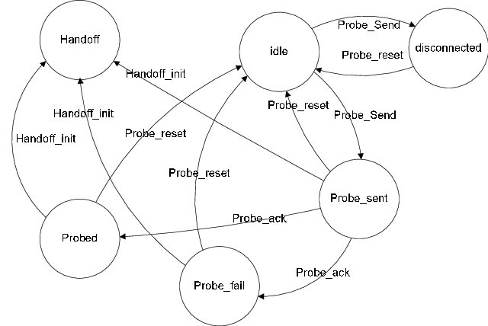

Figure 1 The state diagram

**Answer:**

**(a)** State-based test tree:

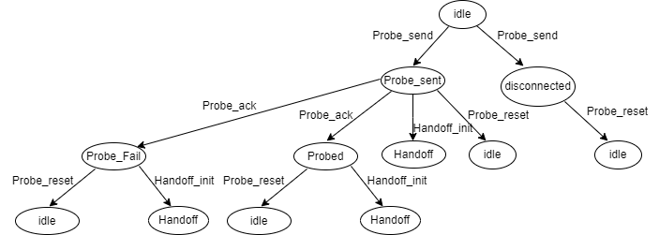

**(b)** State-based paths:

Test cases:

Level #1: idle->Probe_send->Probe_sent

idle->Probe_send->disconnected

Level #2: idle->Probe_send->Probe_sent->Probe_ack->Probe_Fail

idle->Probe_send->Probe_sent->Probe_ack->Probed

idle->Probe_send->Probe_sent->Handoff_init->Handoff

idle->Probe_send->Probe_sent->Probe_reset->idle

idle->Probe_send->disconnected->Probe_reset->idle

Level #3: idle->Probe_send->Probe_sent->Probe_ack->Probe_Fail->Probe_reset->idle

idle->Probe_send->Probe_sent->Probe_ack->Probe_Fail->Handoff_init->Handoff

idle->Probe_send->Probe_sent->Probe_ack->Probed->Probe_reset->idle

idle->Probe_send->Probe_sent->Probe_ack->Probed->Handoff_init->Handoff

**(c)** State testing paths from “idle” to “handoff”:

Below are the state testing paths from “idle” to “handoff”.

Path 1: idle->Probe_send->Probe_sent->Handoff_init->Handoff

Path 2: idle->Probe_send->Probe_sent->Probe_ack->Probe_Fail->Handoff_init->Handoff

Path 3: idle->Probe_send->Probe_sent->Probe_ack->Probed->Handoff_init->Handoff

**Question #4: Driverless Car Validation (20%)**

Please search the google map with images to identify and discover your answer to the following questions for AV Testing context modeling.

1. Develop and present a road context model for a selected 4-way intersection with traffic lights and cross-walking with meters. (6%)
2. Develop and present a road context model for diverse road hazards (based on a well-classified classes) (4%)
3. Develop and present a road context model for people crossing street scenarios (based on a well-classified classes). (6%)
4. Develop a road context model for a school bus scenario (based on a well-classified classes). (4%)

**Answer:**

**a)** Road context model for a selected 4-way intersection with traffic lights and cross-walking with meters is as below.

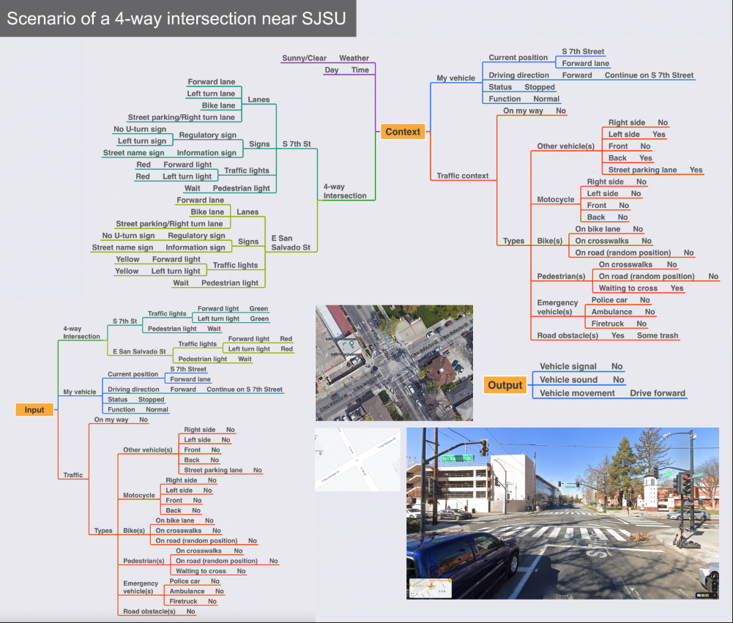

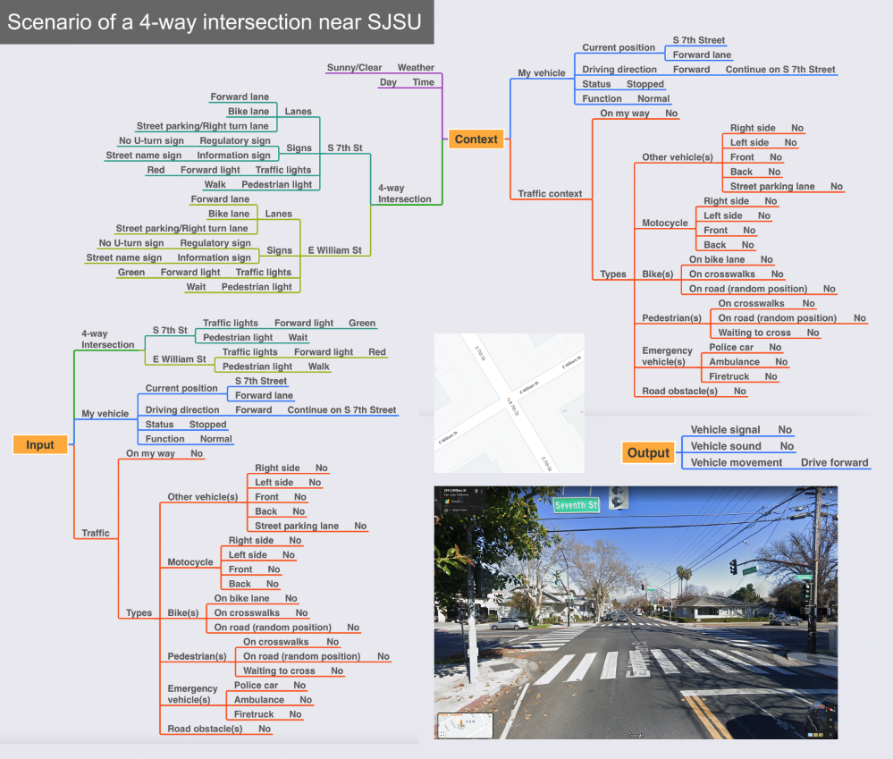

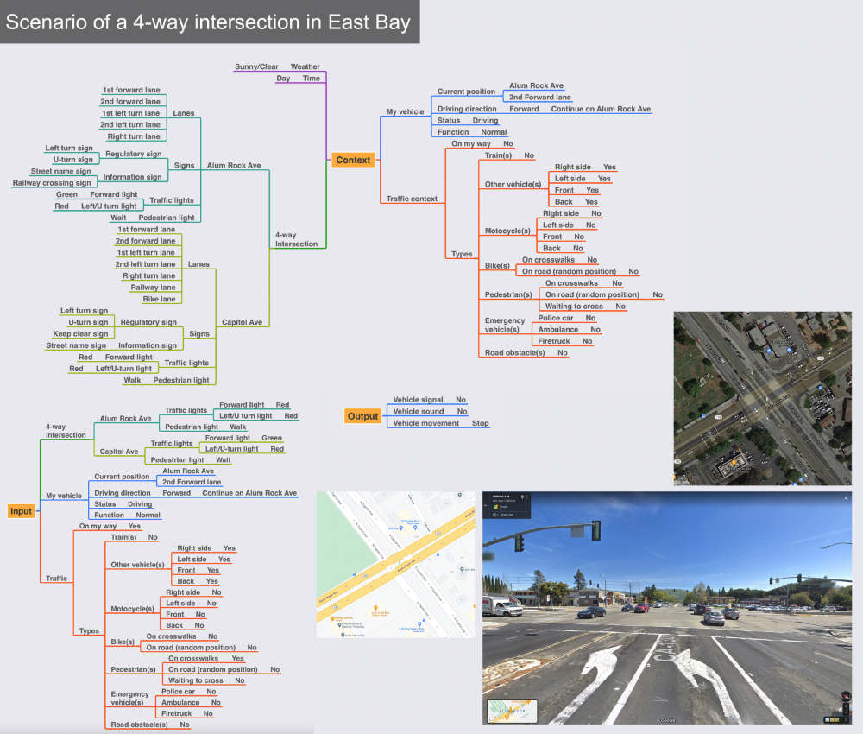

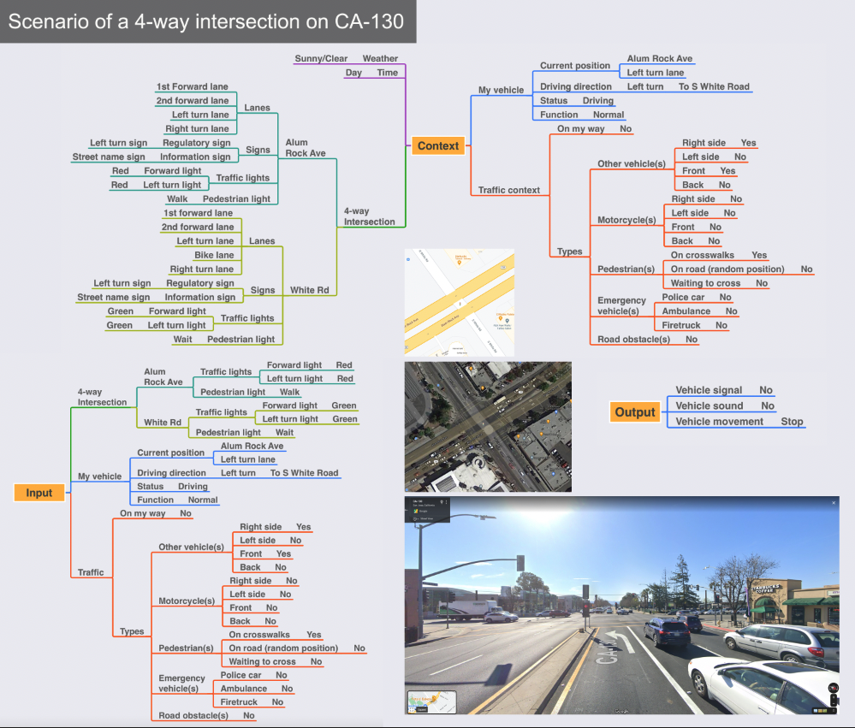

**b)** Road context model for diverse road hazards is as below.

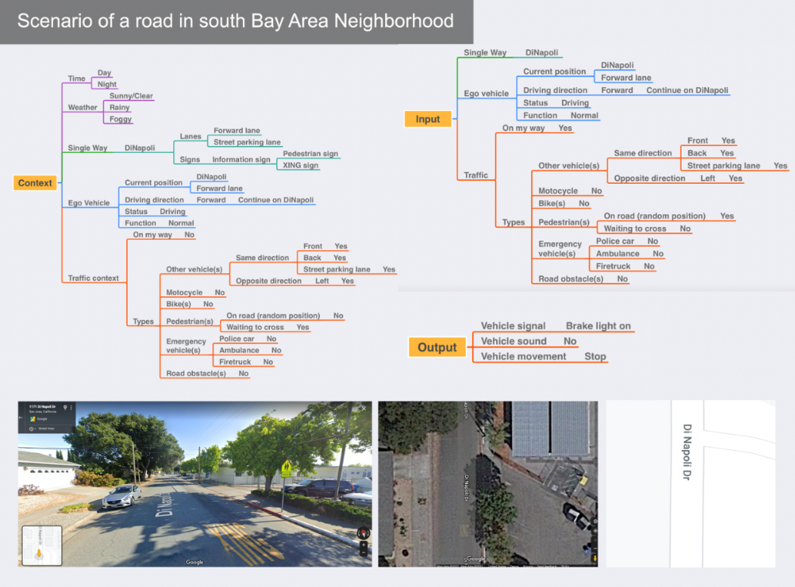

**c)** Road context model for people crossing street scenarios is as below.

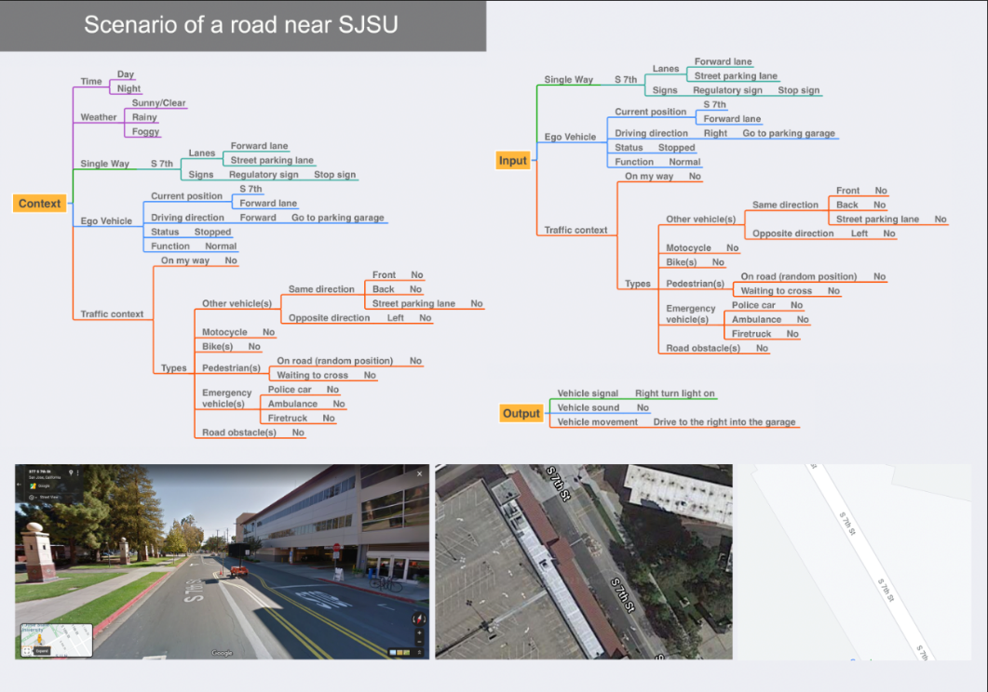

**d)** Road context model for a school bus scenario is as below.

